DAY – 10
DATA MODELING:
- REDUCE THE COMPLEXITY
- INCREASE THE PERFORMANCE
- BUILD THE RELATIONSHIP
WE CAN USE MERGE APPEND AND COMBINE TO MAKE MORE TABLE TO SINGLE TABLE
RELATIONSHIP ABOUT DATA
- DATA PLANNING
- APPLY FILTER/PARAMETERS(COLUMN)
- SET ROW LEVEL RESTRICTION BASED ON ROLE

OLTP VS OLAP:
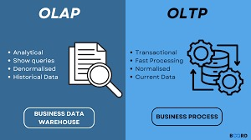

FACT VS DIMENSION TABLE:
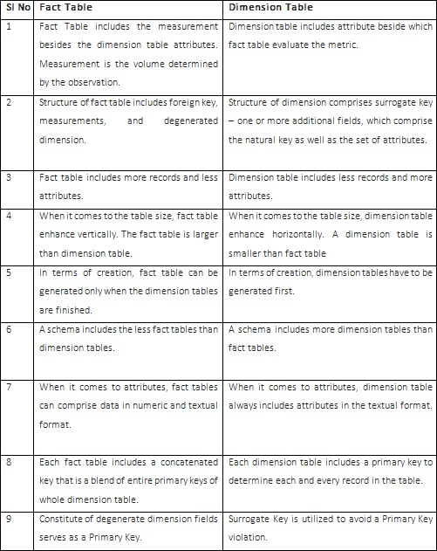
SCHEMA(CATEGORY)
STAR VS SNOWFLAKE SCHEMA
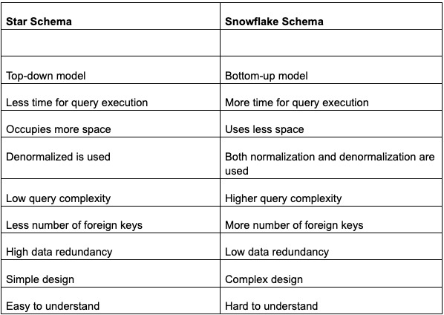
NORMALISE(DATA WILL BE NO REDUDANCY AND CONSISTENT)
DENORMALISE(COMBINE MORE DATA )
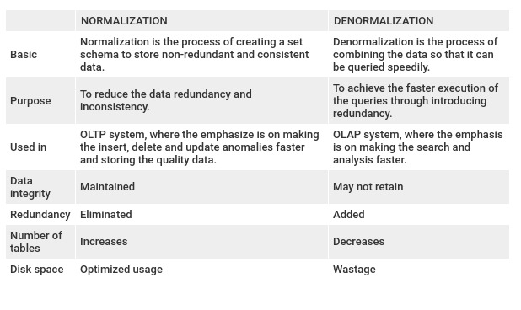
WE CAN UPLOAD FOLDER BUT WE SHOULD USE COMMON TABLE FORMAT FOR COMBINE

DRIVE LINK: https://drive.google.com/drive/folders/1o8lRfIoZVNeY5_fLA7yFqD8ddP7pUToU

FUN REFERENCE: https://learn.microsoft.com/en-us/powerquery-m/power-query-m-function-reference

List fun reference: https://learn.microsoft.com/en-us/powerquery-m/list-functions

DAY – 11
WHEN WE HAVE MULTIPLE FILES IN SAME FOLDER WITH SINGLE EXTENSION WE GO WITH COMBINE FILE
IN COMBINE DATA WITH GO RECENT WISE ORDER EX: UPDATED LATEST IN DATE WISE
AFTER LOADING DATA WE CAN USE APPEND FOR ADDING ROW WISE DATA
IF WE WANT TO ADD COLUMN WISE WE USE MERGE QUERIES AND JOINED USING JOINS
APPEND WE CAN SELECT ORDERWISE

DAY -12
DATA MODELING : MAKING RELATIONSHIP AND MANAGE ROLES
CARDINALITY:
ONE-ONE
ONE-MANY
MANY-ONE
MANY-MANY

